**Deliverable 2:**

**• Project: Develop a simple web application that integrates a frontend (using React) with a**

**backend (using Node.js/Express). Document the setup process, code snippets, and**

**screenshots of the working application.**

Setup steps for app-

1. Folder Setup

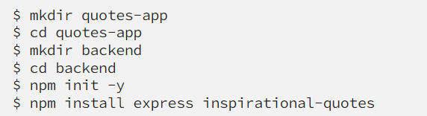

# 2.) The Backend

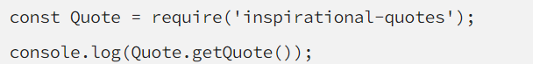

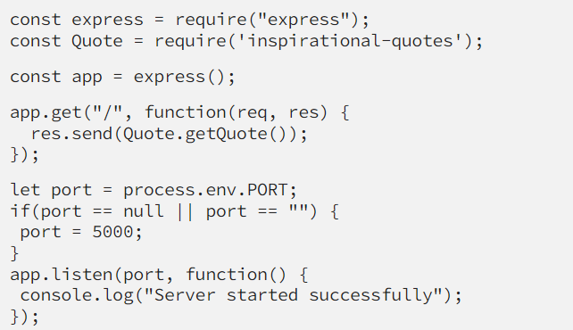

# 3.)The Frontend

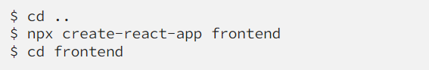

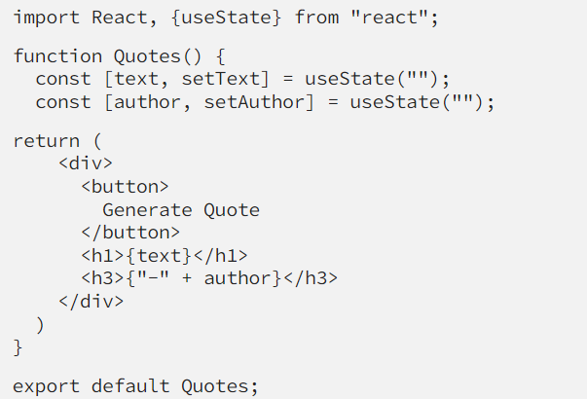

App.js

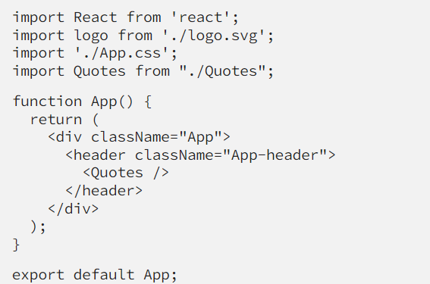

Install axios

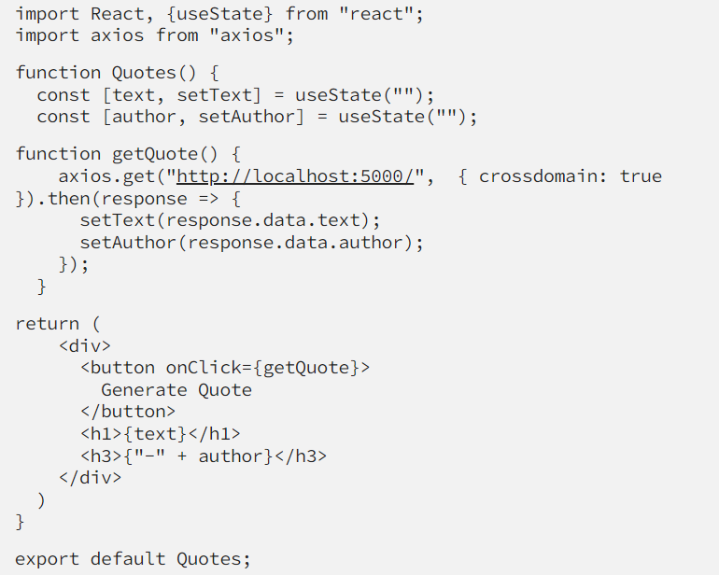

Result-

